Eate Sprint 3 Plan

Circular Barter & Gift

Release 1.0

Completion Date: 2/16

Revision Number: 1

Scrum Master: Daniel

**Sprint Goal**:

**Tasks**

*User Story 1: (5) As an item poster, I want to be able to edit or delete a post because I no longer want to trade an item.* ***Must***

* Tasks
  + 1a Associate each post with a user (1)
  + 1b Associate listing with its offers (1)
  + 1c When a post is deleted update both the listings and offers tables in the backend (2)
  + 1d Add a delete button (1)

User Story 2: *(10) As someone who had made an offer, I want to be able to communicate and agree to an exchange with them without giving my phone number or email away.* ***Must***

* Tasks
  + 2a Create a messaging interface (1)
  + 2b Store messages in the backend (3)
  + 2c Send and fetch messages (3)

*User Story 3: (5) As someone who posted an item listing, I want to be notified within the website when I get a trade offer for an item.* ***Could***

* Tasks
  + 3a Create a notification tray interface (2)
  + 3b Augment the offers table with a variable that it tracks whether the user has seen it (1)
  + 3c Have new offers propagate the notifications tray (2)

*User Story 4: (5) As someone who wants to give something away, I want to be able to create and post a listing so that other users can make offers.* ***Could***

* Tasks
  + 4a Send post request to server and have it stored in the database (2)
  + 4b Make a well-styled posting interface (3)

*User Story 5: (5) As someone interested in an item listed, I’d like to make an offer to exchange it for something I have.* ***Must***

* Tasks
  + 5a Update the backend so that it receives offer requests from clients and updates the database with the new offer (2)
  + 5b Create a view to see all offers you have made as a user (1)
  + 5c Create a list view to see all offers for a particular listing (1)
  + 5d Add a button to each post for the user to make the offer (1)

**Team Roles**

* Ian (Product Owner, UI Designer)
* Kenneth (backend)
* Gonzalo (developer, full stack)
* Hengtian (developer, frontend)
* Micheal (developer, backend)
* Daniel (Scrum Master, developer)

**Initial Task Assignment**

* Ian: 2a, 3a, 4b
* Kenneth: 1a, 1b, 1c, 1d
* Gonzalo: 5a, 5b, 5c, 5d
* Hengtian: 4a, 4b
* Micheal: 2a, 2b, 2c
* Daniel: 3b, 3c, 4a

Infrastructure Tasks:

Spikes

* Learn how to create and store data (chat history) into each user
* Learn how to integrate imgur upload for seamless

**Initial burnup chart**

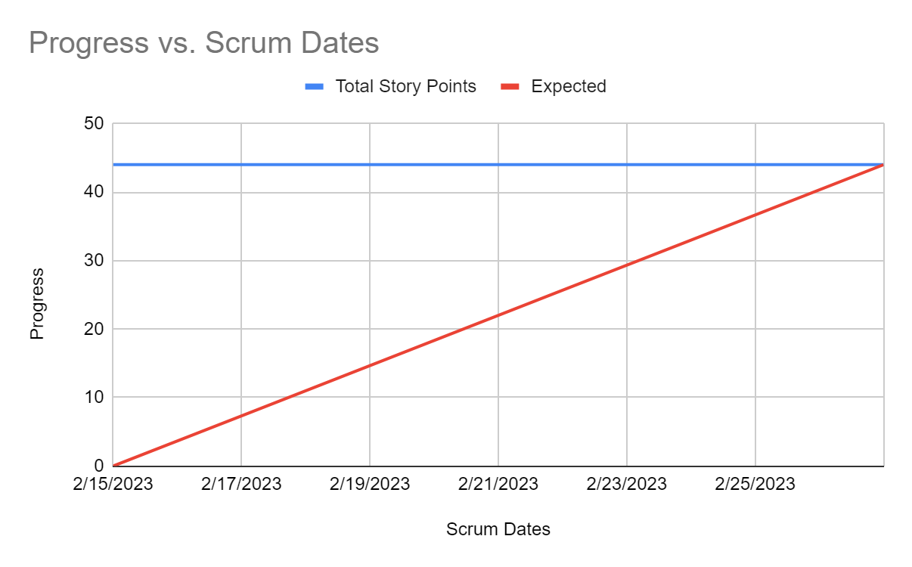

[**Initial Scrum Board**](https://trello.com/invite/b/gx6MgIyB/ATTI05a8695a17ffdbae9ebdfa6643b1ffb3EFEE51C2/tasks)

**Scrum Times:**

9:05 - 9:20 MWF